**Lab Session 12-10-2023**

Syntax:

Delete from table_name

Where[condition]

Q.Delete a customer whose id is 102

Delete from customer where content_id = 102

Q. Delete all records from customers

Delete from customers;

Q. Delete content details when content_id is provided

Delete from netflix where contentid = 102;

Q. Delete the contents with less rating

delete from netflix where rating < 3.5;

**OR and AND Operators**

Select col1 , col2, colN from table_name

Where [condition] and [condition]..and [conditionN]

Select * from suppliers where (state = “MAHARASHTRA” and supplier_name=”SAHARA”)

OR (supplier_id < 5000);

**Comparison Operators**

Equal (=)

Select * from customers where last_name = ‘Maria’;

Not Equal (!= , <> )

Select * from customers where last_name <> ‘Maria’;

Less than , Greater than

Select * from customers where age > 60;

Select * from customers where age >= 18;

Select * from customers where age < 45;

Q. get the content details with number of episodes more than 5

select * from netflix where epicount > 5;

Q. get the title and description of comedy series

Select title, description from Netflix where genre = 'comedy';

Q. get the serires details released before 19/10/21

Select * from Netflix where releasedate > '18/10/2021';

Q. get the id and director of series with rating 4.0

Select contentid, director from Netflix where rating > 4.0;

Q. Get all the details where duration is less than 500

select * from netflix where duration > 250;

Q. Get the title and director of contents with 3 seasons and rating > 4.0

select title,director from netflix where seasons >= 5 and rating >= 3.5;

Q. Get the contentids of comedy or action series.

select contentid from netflix where genre = 'comedy' or genre = 'Action';

BETWEEN/ NOT BETWEEN

Syntax

Expression BETWEEN value1 and value2;

Expression NOT BETWEEN value1 and value2;

Example:

select * from customers where customer_id between 4000 and 4999;

select * from customers where customer_id not between 4000 and 4999;

Q. Get the content ID and title of series with episode count more than 5 and less than 100.

select contentid, title from netflix where epicount between 5 and 100;

Q. Get the directors of series with duration between 200 to 300;

Q. Get the series with price ranges in 199 to 499;

Q. get the title and sesaons where rate not in 299 to 399

Q. Get the details of series not in comedy genre

Select * from Netflix where genre <> 'comedy';

Logical Operators

Q. Retrieve the id and title of the series in comedy genre with price more than 399

Q. Get the details of series of thriller or horror genre;

select * from netflix where genre = 'action' or genre = 'comedy';

select * from netflix where genre in ('action','comedy');

Q. get details of series other than action genre;

select * from netflix where genre not in ('action','comedy','Comedy','Action');

DISTINCT

Select distinct expressions from tables [where conditions];

Select distinct state from customers where last_name = “Panchal”;

Q. Get the genre of series with rating = 3.9

DUAL Temp table in Oracle:

Arthimetic Operators

Q. Display the price after deducting 50 rupees

Select contentid, price-50 from netflix;

Q. Display the episode count increased by 20;

Select contentid, epicount+20 from Netflix;

Q. Display the price after increasing by 3%

Select contentid, rate+rate*0.03 as hikeprice from Netflix;

LIKE : % or _:

Syntax:

[expression] where col1 like ‘%value1%’

Q. get the name of directors whose name starts with ‘k’

select distinct director from netflix where director like 'k%';

Q. Get the series and title which contains ‘man’

Q. get the directors name ending with p

select distinct director from netflix where director like '%p';

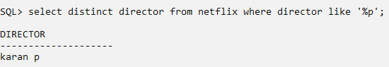

Sub Queries

Q. fetch the id series with price greater than the price of series in comedy genere

Select contentid from Netflix where rate >= (select max(rate) from netflix where genre = 'Comedy');

Q. Fetch the title and director of the series with duration more than the duration of the series of the series with episode count more than 5.

Select title,director from netflix where duration >= (select max(duration) from netflix where epicount >= 5);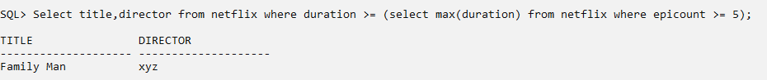

ORDER BY

Default ascending order

Order By clause is used to sort the data in ascending or descending order

Select column-list

From table_name [where condition] ORDER BY [col1, col2,…] [asc|desc]

Q. Fetch the contented and title of series in ascending order of price

select contentid,title from netflix order by rate asc;

Q. Fetch the contented and price in descending order of release data;

select contentid,rate from netflix order by releasedate desc;

select contentid,director from netflix order by genre;

COMMIT and ROLLBACK

